**Experiment 2**

Valiveti Manikanta Bhuvanesh

19BCD7088

AIM: Visualizing data using R with different type of graphs and charts

**3.Histogram**

**Code:**

x <-mtcars$mpg

h<-hist(x, breaks=10, col='orange', xlab="Miles Per Gallon", main="Histogram with Normal Curve")

**OutPut:**

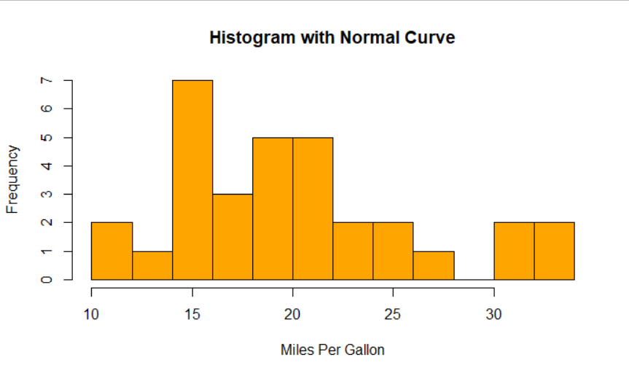

**Code:**

y <-PlantGrowth$weight

h<-hist(y, breaks=10, col=rainbow(y), xlab="Group", main="Histogram with Normal Curve")

**Output:**

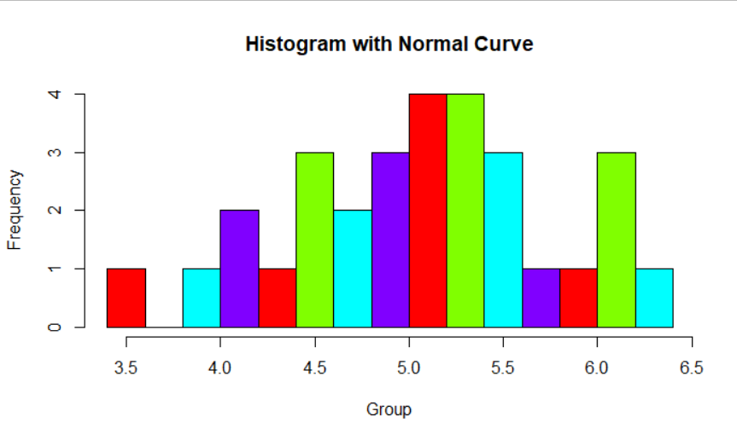

**Code:**

h<-hist(y,breaks = 10,col='blue',ylim = c(0,5),border='yellow',xlab = 'Group',main="Histogram with Normal Curve")

text(h$mids,h$counts,labels=h$counts,adj=c(0.5,-0.5))

**Output:**

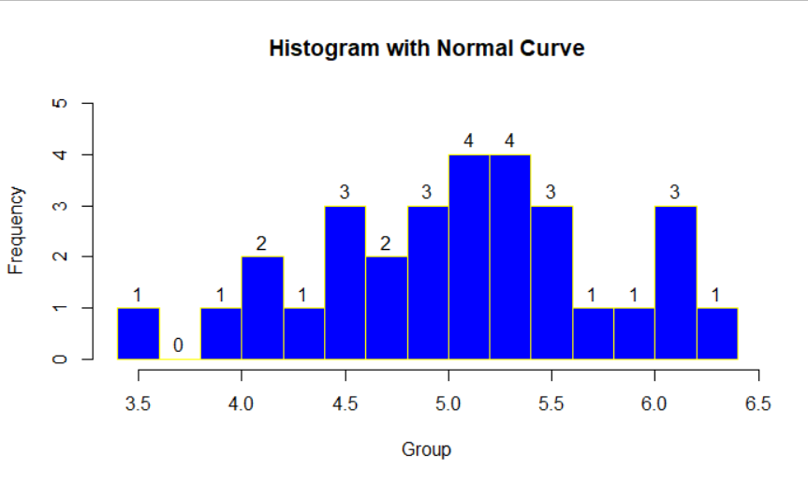

**2.BoxPlot**

**Code:**

input <-mtcars[,c('mpg','cyl')]

print(head(input))

png(file="boxplot.png")

b<-boxplot(mpg~cyl, data = mtcars,notch=TRUE,varwidth=TRUE, xlab = "Number of Cylinders", ylab="Miles Per Gallon", main = "Mileage Data")

**Output:**

